# Activity Diagram explanation:

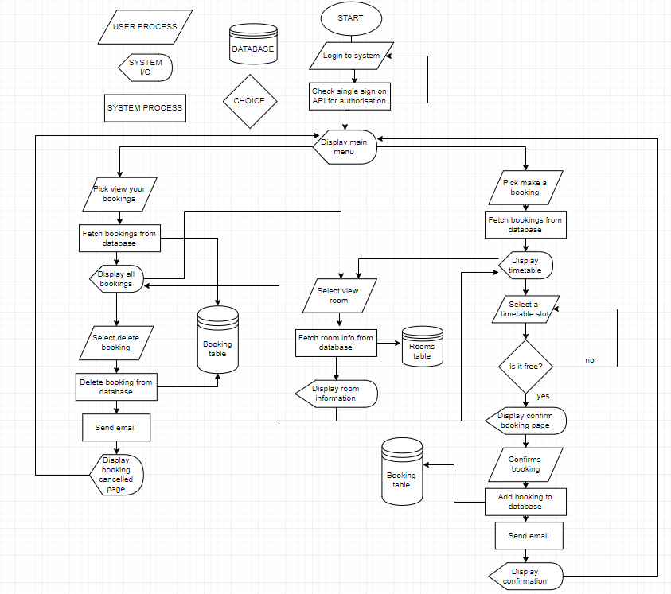

This UML diagram is made in the form of a flowchart used to describe the flow from one activity to another. An activity is an operation of the system, whether that be a user process, system input/output, system process and choice. Each of these operations has their own unique shape within the diagram to make visualisation of the operations easier. This can be seen with the key at the top of the diagram.

So, to explain the flowchart above, it first starts with the user logging into the system through the imported UoB ‘Single Sign On’ integration. From here, the user is taken to the main menu where they can then choose whether they would like to make a new booking or view their existing bookings.

Make a booking:

Once this option is selected, the system accesses the database and fetches all the bookings from the database (from all userIDs) and displays it in a timetable type format. The user can then select the specific timetable slot for which he would like to place a booking in. If it is free, the user will then be taken to a page to confirm his booking. Once the user has confirmed the booking, the system will instantiate a new booking object and set all the attributes appropriately. This booking object is then used to insert a new record into the Booking table within the database. An email is then sent once the booking has been saved, and the user is redirected to the main menu.

Viewing a booking:

Once this option is selected, the system accesses the database and fetches all the bookings of the user’s unique userID from the database. The constructor from the booking class is called (for each booking the user has) and a new booking is instantiated with the details from that specific record in the database. Each object is then displayed within a table (with their associated rooms shown), of which the user can select a booking they would like to delete. If the user selects to delete a booking, the booking.deleteBooking method is called and the system once again accesses the database and deletes the related record from the Booking table. An email is then sent to confirm the deletion, and the user is redirected to the main page.

View room functionality:

This view room function is used twice in the system (as shown in the flowchart). It is called when: 1) The user wants to make a new booking, and the timetable for each room is shown. 2) The user wants to view their bookings, and a list of the bookings and associated rooms are shown. This view room function works by fetching the specific room information from the Rooms table within the database. This fetched data is then formatted onto a webpage and shown to the user.